Concise and clear terminology for the neutron activation tool
UI name: Thermal NAA Tool (with a subtitle: Powered by ITM Medical Isotopes GmbH)
Full name (for documentation): Thermal Neutron Activation & Analysis Tool (ITM Medical Isotopes GmbH)

LAYOUT
Looks really very good and professional but on the left side there is unused space:
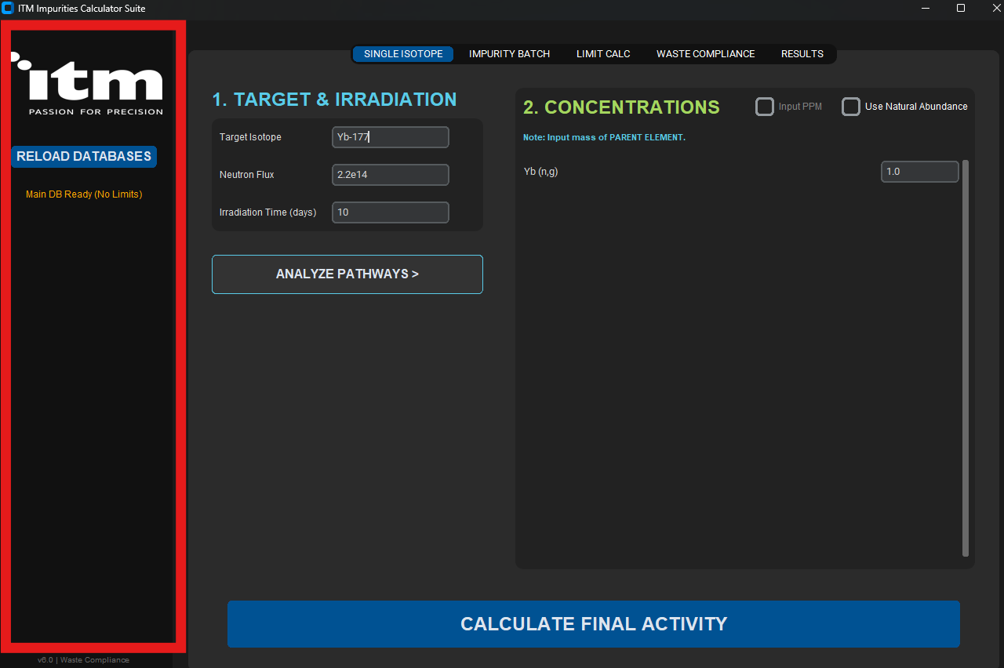
Either the module buttons should migrate on the left panel under the button “RELOAD DATABASES”, or this left panel should not be deleted and the button for “RELOAD DATABASES” moved to the bottom corner (right or left – relatively small, because the correct database is already automatically uploaded by default).

MODULE(S)

- SINGLE ISOTOPE
SINGLE ISOTOPE = Single Isotope Activation OK
TARGET & IRRADIATION = Product Isotope & Irradiation Parameters OK
Target Isotope = Activated Product Isotope OK
Neutron Flux = Neutron Flux ([n/cm²·s]) OK
ANALYZE PATHWAYS = Show Possible Reaction Pathways OK
CONCENTRATIONS = Initial Material Composition OK
Note: Input mass of PARENT ELEMENT = Enter mass or concentration of parent isotope(s) contributing to activation. OK
Use Natural Abundance = Assume Natural Isotopic Abundance OK
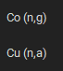 Including atomic number, e.g. Co-59 (n,g), to make it more directly visible without the necessity of thinking of the parent isotope. In the results it’s already correctly there. OK
 add also check box for mass (the user must actively select the unit, otherwise the calculation will not execute (pop-up window warning) OK(different)
PPM = ppm (small letters always) OK
Add explanation: if ppm is used, to what it is related (not clear directly)
Results section
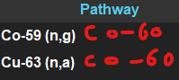 including visible product (even though it’s clear) OK
If possible, use Greek letters for the particles throughout the whole tool OK
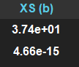 XS = explain in words “Cross Section (barn)”, incl. Note: Reaction cross section at thermal neutron energy, expressed in barns (1 barn = 10⁻²⁴ cm²). OK
Act (Bq) = Activity (Bq) OK
Act (Ci) = Activity (Ci) OK
Atoms = Number of Atoms (short explanation could be added: Total number of atoms of the activated isotope after irradiation.) OK
Recommended Final Table Header
| Reaction Pathway | Cross Section (barn) | Activity (Bq) | Activity (Ci) | Number of Atoms |
Export options:
- CSV already there
- PDF protocol- OK (can be improved)

- IMPURITY BATCH
IMPURITY BATCH = Impurity Activation
INPUT IMPURITIES (PPM) = Impurity Concentrations in ppm values related to given Ytterbium Oxide Mass
Format: Element PPM (e.g., Fe 50, Zn 10) = Enter impurity elements and their concentrations in ppm, relative to the specified Yb₂O₃ sample mass (e.g., Fe 50, Zn 2.5 → Element abbreviation + space + ppm value).
SETTINGS = Irradiation Parameters
Total Sample Mass (g) = Yb₂O₃ Mass (g)
Neutron Flux = Neutron Flux ([n/cm²·s])
Time (days) = Irradiation Time (days)
ANALYZE IMPURITIES = Calculate Impurity Activation
Use Natural Abundance = Assume Natural Isotopic Abundance
Result section
Impurity = Impurity Isotope (including atomic number, e.g. Au-197, for clarity) ????????
Conc (ppm) = Concentration (ppm)
Reaction = Greek letters if possible
Act (Bq) = Activity (Bq)
Act (Ci) = Activity (Ci)
Order of the rows based on the activity from highest to lowest, I think already there
Export options:
- CSV already there
- PDF protocol

- Single Isotope Activation
Add: “Cooling Time (days)” using radioactive decay law:
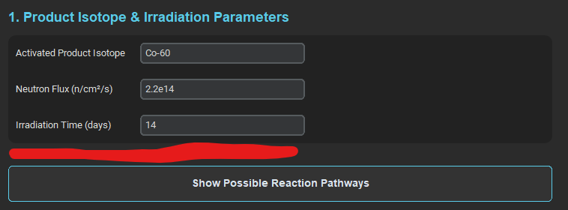
Especially relevant for radioisotopes produced through radioactive decays of activated products.

Yb₂O₃:

The full name here, as mentioned before:


Unify formatting:
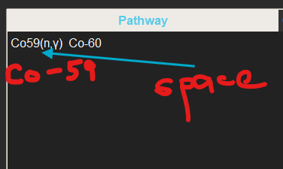
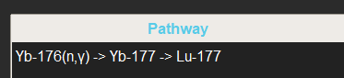
Yb-176 (n,γ) Yb-177 Lu-177

Too many decimals:
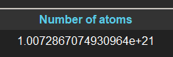

This information can be omitted, it is clear from the path:
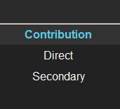

I think the exported data do not correspond to the inserted and calculated data, maybe it’s just formatting issue:
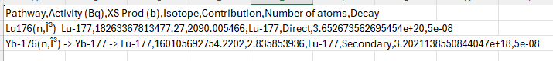

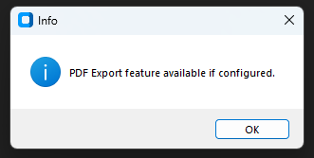

Can the font of the button be white and only the first letter as capital letter?
 such as here, including the same size:


Unify formatting of neutron flux units:
Single isotope activation: 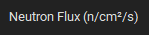
Impurity activation: 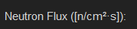

- Impurity activation

Could this text field be composed of columns? Making an editable table.
Column 1 = Element
Column 2 = Amount
Etc…
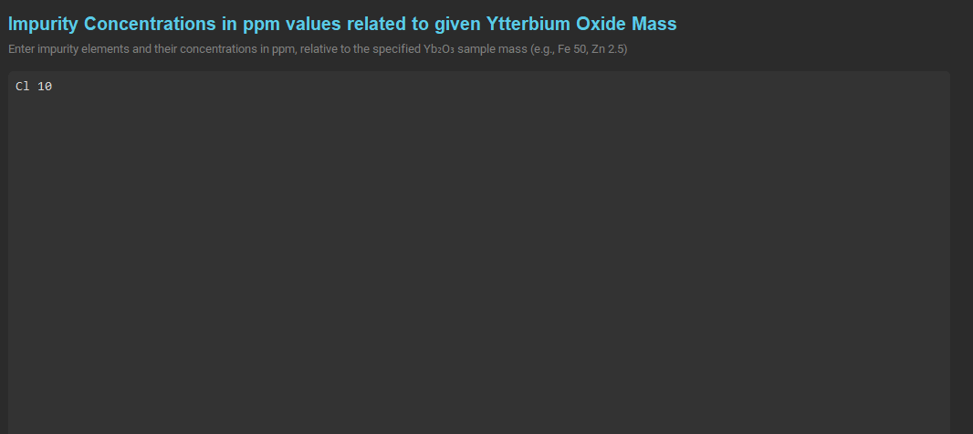

Add the function cooling time:
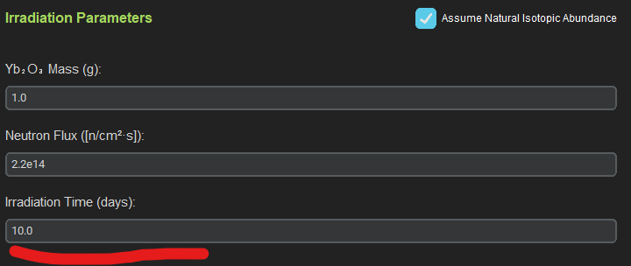

Impurity Element, not isotope:
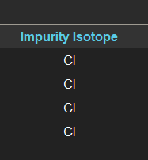

Type = Pathway: add reaction e.g. (n,γ), not direct/indirect
